Milestone 1 – Documentation

***1. Team name and names of members***

Team name: Group 6

James Czeredys – s3900781

Ned Pearson - s3844470

Rita Lam Cordeiro – s3947881

Raphael Bullen - s3897844

Yash Dhukate - s3898134

Yiqi (Gilbert) Du - s3665887

***2. Contribution Statement, with details for each team member***

|  |  |  |
| --- | --- | --- |
| **Name** | **Contribution %** | **Items contributed** |
| James | 16.6% | User stories, Tasks, Acceptance Criteria, Software Architecture, Dependences, SCRUM master, Documentation |
| Ned | 16.6% | User stories, Tasks, Acceptance Criteria, Wireframes |
| Rita | 16.6% | User stories, Tasks, Acceptance Criteria, |
| Raphael | 16.6% | User stories, Tasks, Acceptance Criteria, Non-Functional requirements |
| Yash | 16.6% | User stories, Tasks, Acceptance Criteria, Wireframes |
| Yiqi | 16.6% | User stories, Tasks, Acceptance Criteria, Iteration planning, Class diagrams, ER diagram |

***3. Links to GitHub repo and Issue tracker board***

GitHub repo:

<https://github.com/cosc2299-sept-2023/team-project-group-p07-06/tree/a0009839cf11cd1b37d52f4f2e3f649075b5707c>

Board:

<https://github.com/orgs/cosc2299-sept-2023/projects/62>

***4. Meeting Minutes and communication***

Communication viewable under ‘SEPT - Group 6’ chat in Microsoft Teams

# **Meeting Week 1:**

Unresolved questions and initial product design:

* Will different shops charge different delivery fees?
* Summation of delivery fees?
* Display when shops are out of stock, display how much stock is left.
* Category page, search bar for specific search
* Partial search/autocomplete feature
* Do we need customer accounts?
* Do we need staff accounts for staff functions? (not mentioned in requirements)
* Order ID, order database (deliveries)
* Pages: Main, Search results, Product page, Cart page, Delivery page
* Mockup:

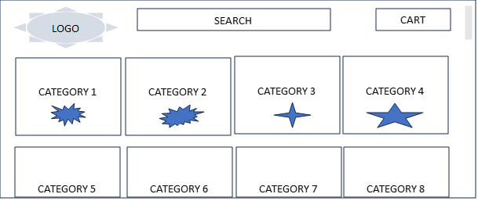

# **Meeting Week 2:**

**Discussed Topics:**

Finalise user stories and acceptance criteria

Transfer user stories to GitHub project board

Start working on SRS

Start working on breaking down user stories to tasks

Finalise wireframes

# **Meeting Week 3:**

**Discussed Topics:**

Ensure every task is labelled, made an issue, assigned, and given an estimate

Individual components- create video and fill in contribution statement

Complement SRS

Diagrams – Class and entity relationship diagrams

Finalise submission – making sure all documents in order and present in GitHub

***6. Each team member record up to 2 minutes video, explain your work and contribution, and quickly show it. Add all videos to a folder called videos and zip the folder.***

Videos found in GitHub Repo under /docs/Milestone1/videos.zip.